**Q) What steps need to be followed to run your website for testing (in addition to the steps outlined in the prerequisite section)?  
Ans)**

1. Decompress the zip file **CS612_HW3_Osaid_Khan.zip**
2. Open the **server.js** file and the value for the PG pool as highlighted in the screenshot

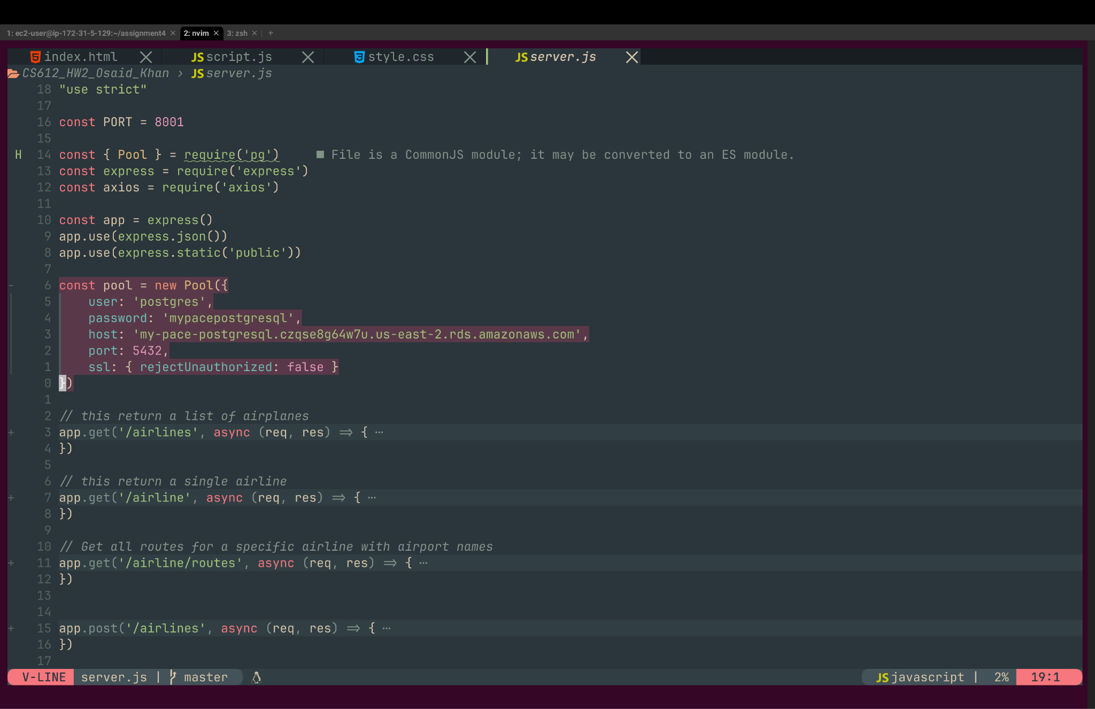

1. Run **npm install && npm start**
2. Navigate to **localhost:8001**
3. **To Test Requirement - A user selects a country to view all airlines and the airports in the country selected.**
4. Click on the first dropdown **“Select A country“** Under the H1 header “**Airline Information System”**
5. Select an option
6. Click on the button **“View Airlines & Airports”**

**Expected Result ->**

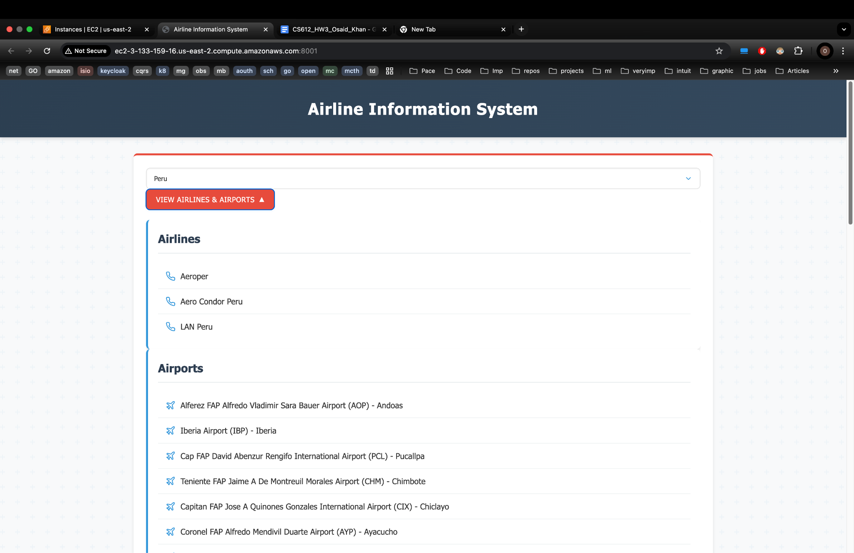

1. **To Test Requirement - A user selects an airline to view the airports and/or routes the airline selected flies.**
2. Click on the **Select Airline** Drop Down above the **View Route** Button
3. Select an option
4. Click on the button **“View Route”**

**Expected Result ->**

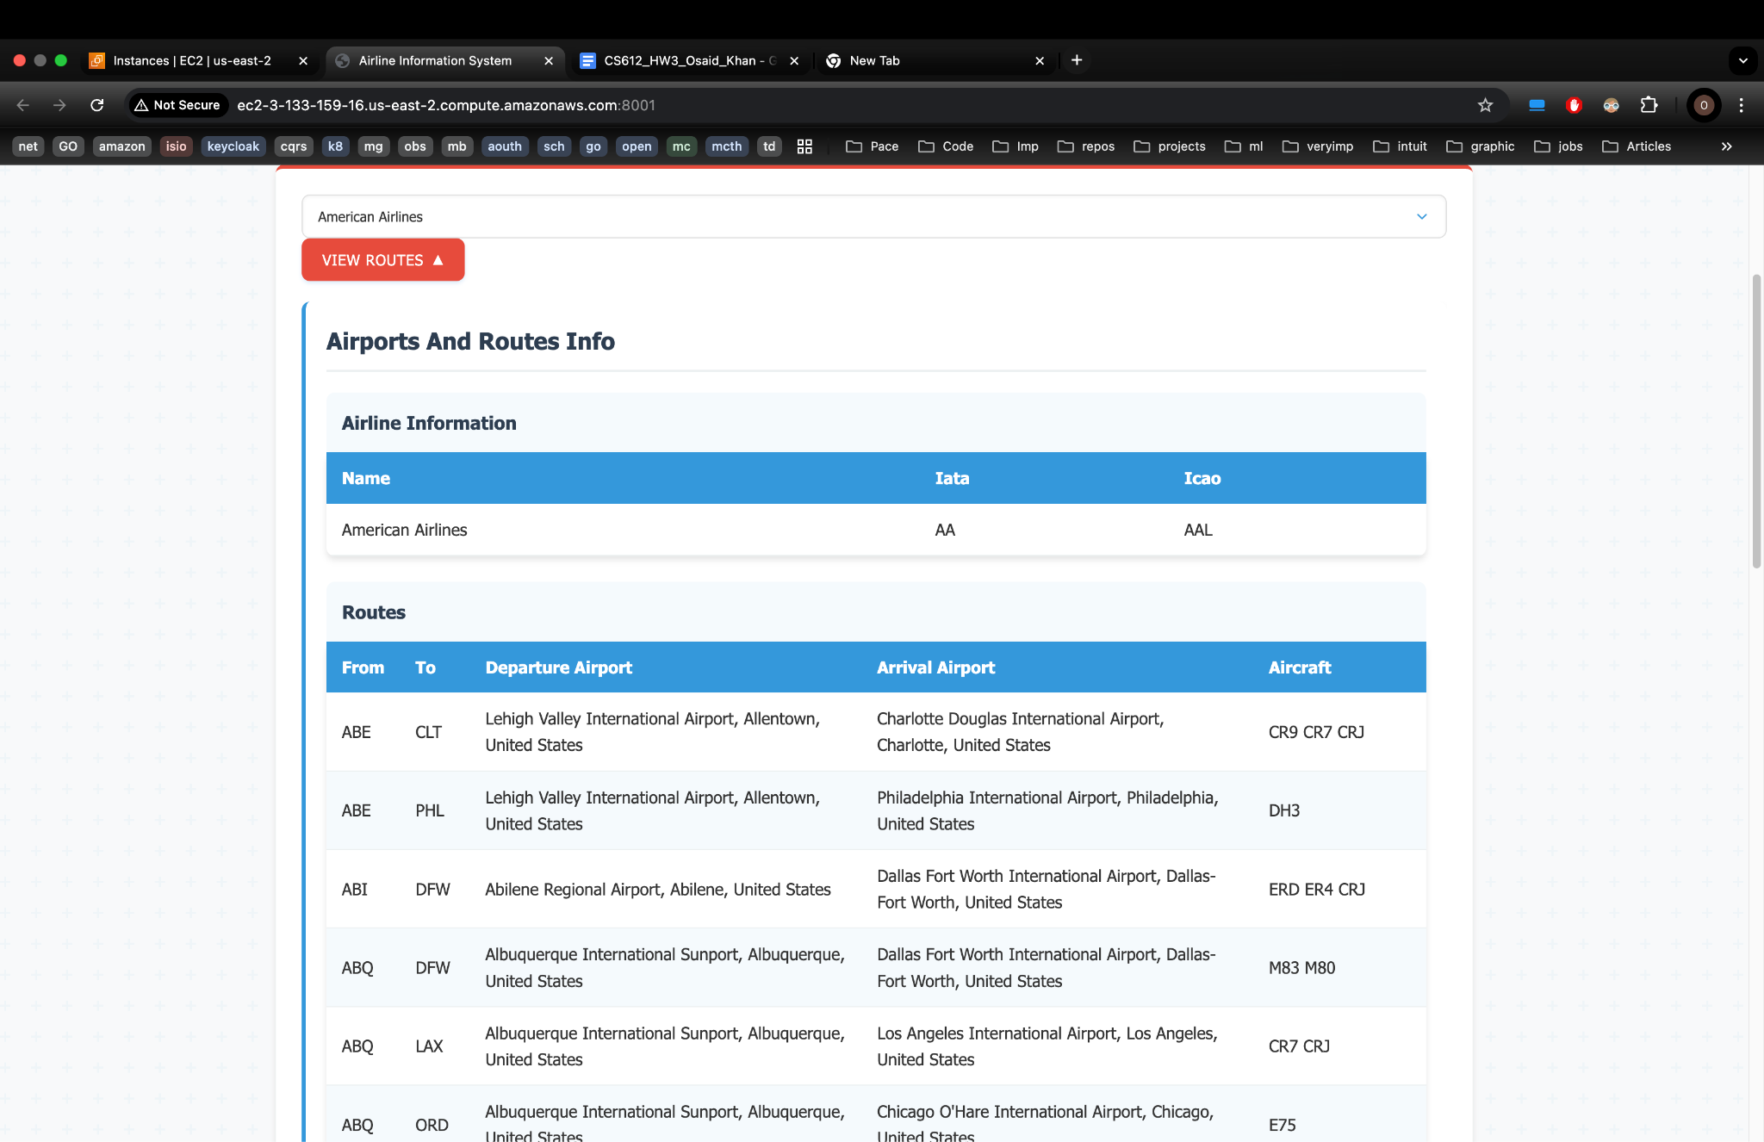

1. **To Test Requirement - A user selects an airport to view the details about the airport (e.g., name, airport codes, current weather, etc.).**
2. Click on the **Select Airport** Drop Down above the **View Details** Button
3. Select an option
4. Click on the button **“View Details”**

**Expected Result ->** 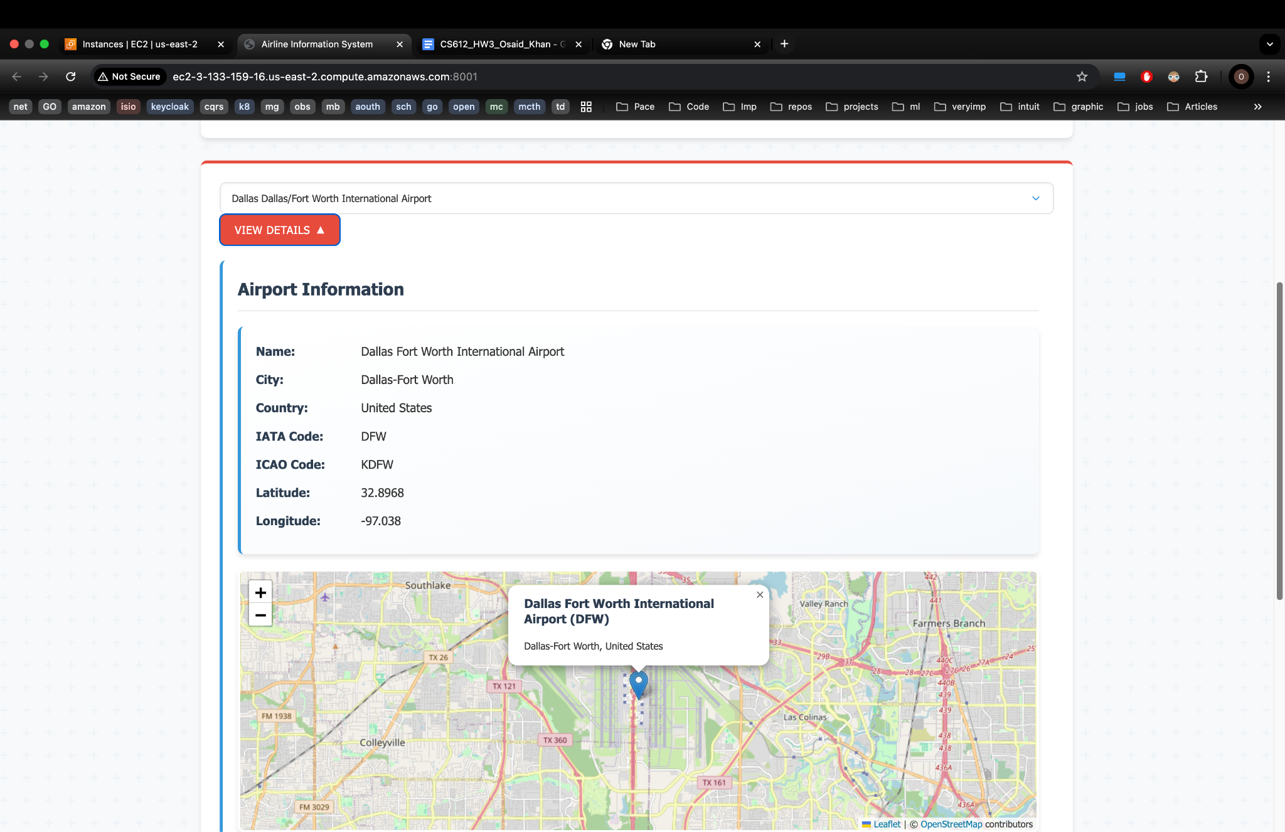

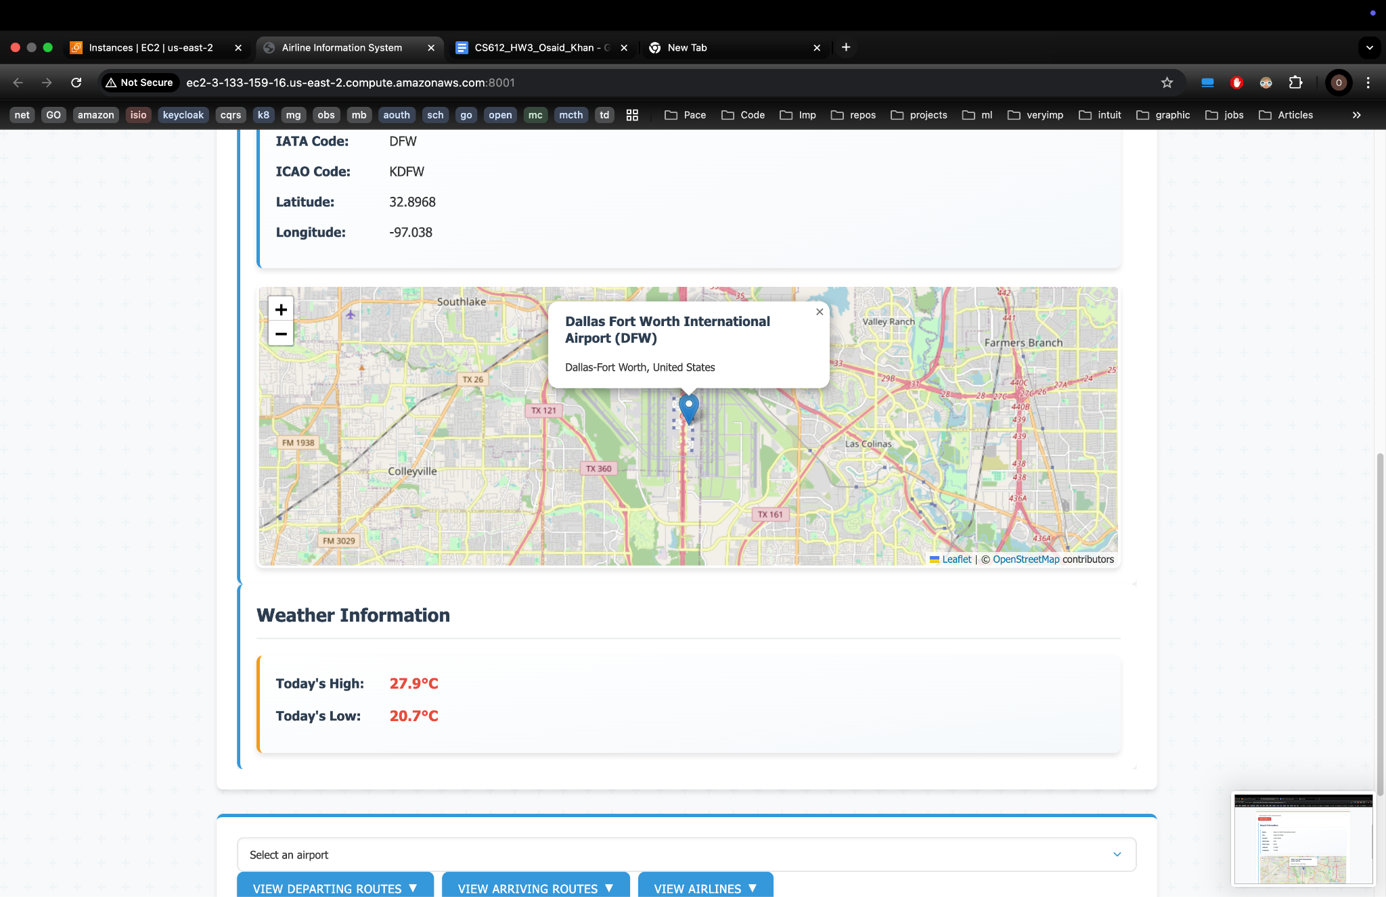

1. **To Test Requirement - A user selects an airport to view the routes originating from the airport selected.**
2. Click on the **Select Airport** Drop Down above the **View Departing Routes** Button
3. Select an option
4. Click on the button **“View Departing Routes”**

**Expected Result ->**

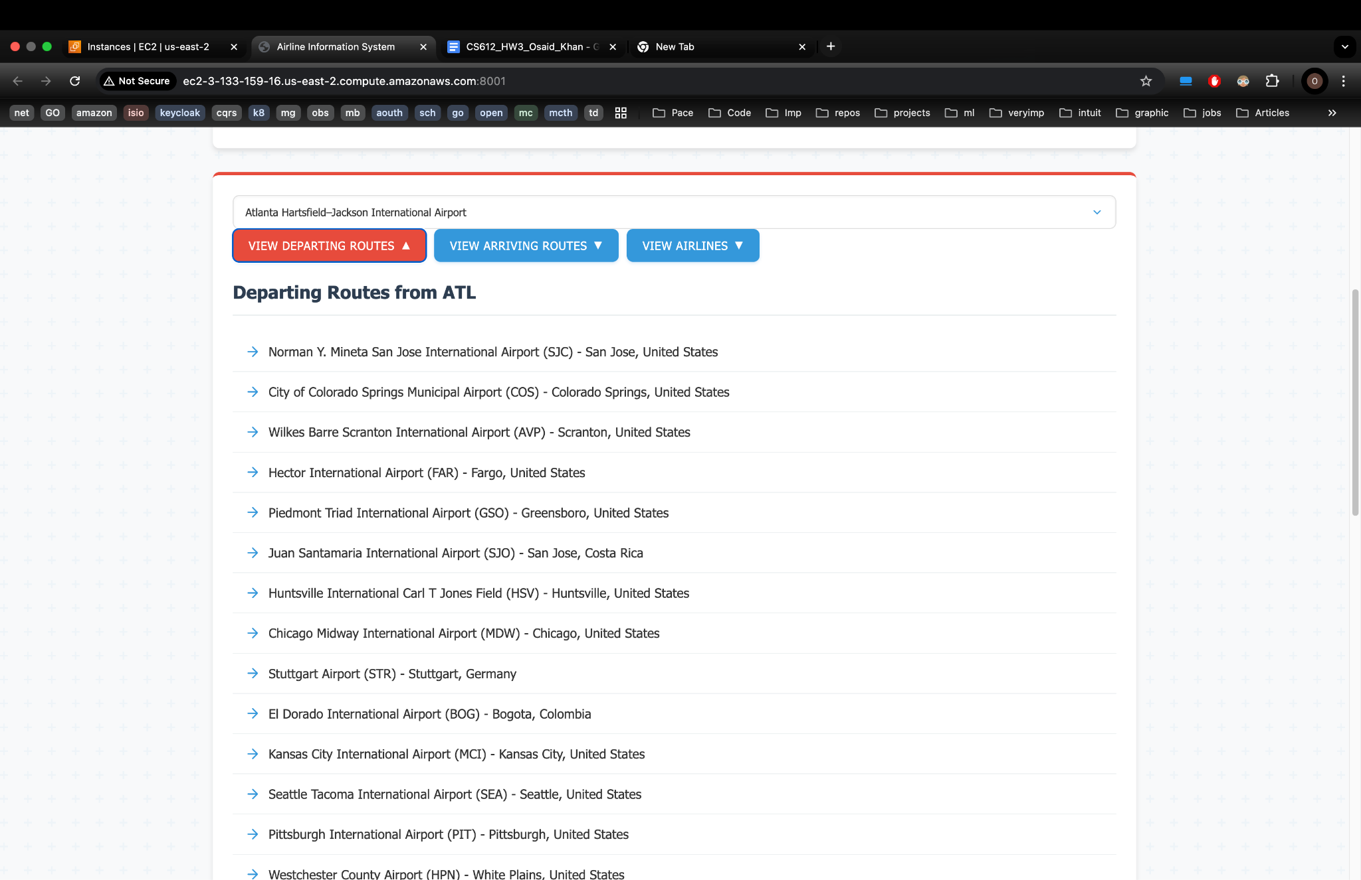

1. **To Test Requirement - A user selects an airport to view the routes arriving at the airport selected.**
2. Click on the **Select Airport** Drop Down above the **View Arriving Routes** Button
3. Select an option
4. Click on the button **“View Arriving Routes”**

**Expected Result ->**

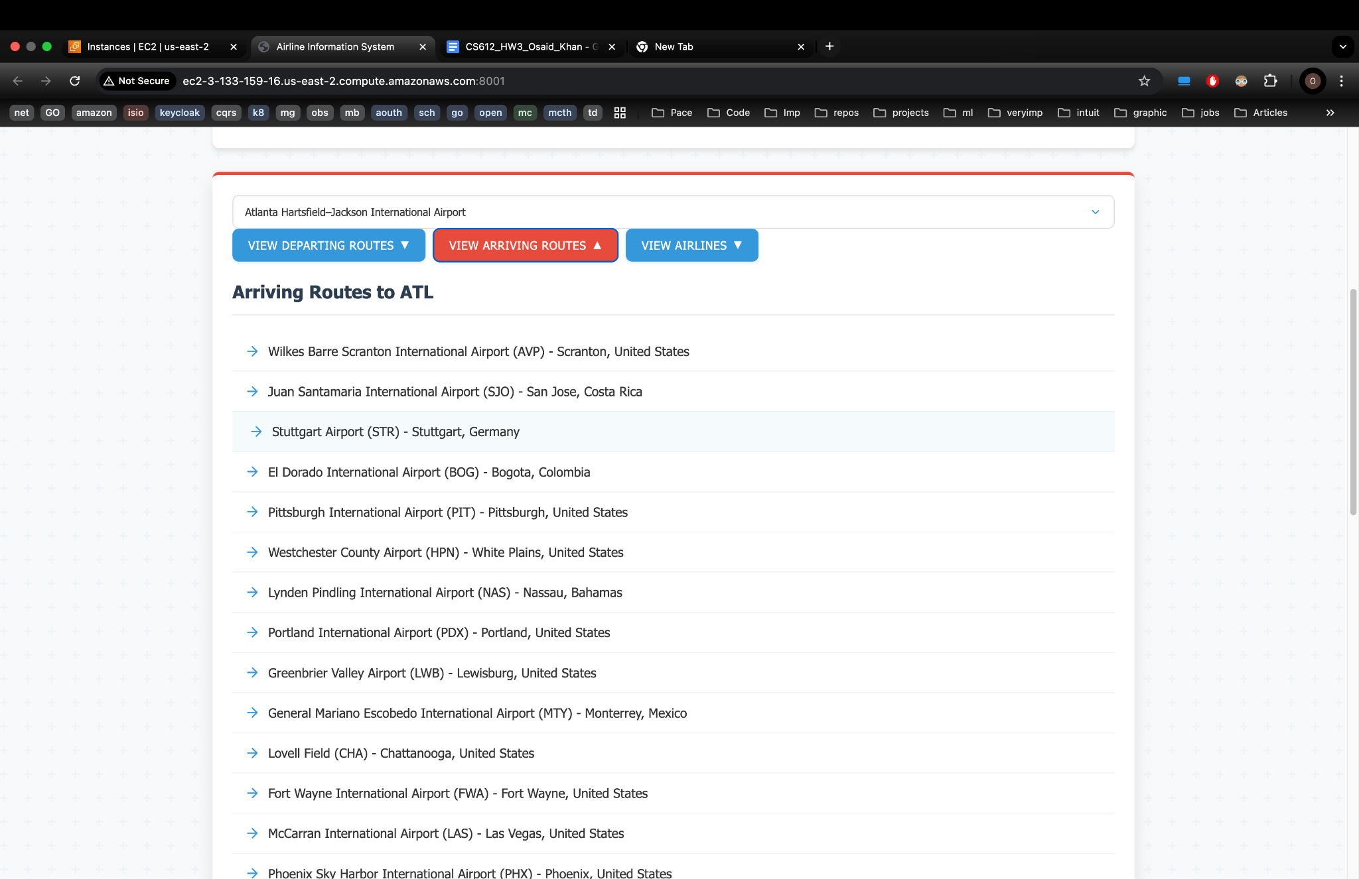

1. **To Test Requirement - A user selects an airport to view all airlines flying to/from the airports selected.**
2. Click on the **Select Airport** Drop Down above the **View Airlines** Button
3. Select an option
4. Click on the button **“View Airlines”**

**Expected Result ->**

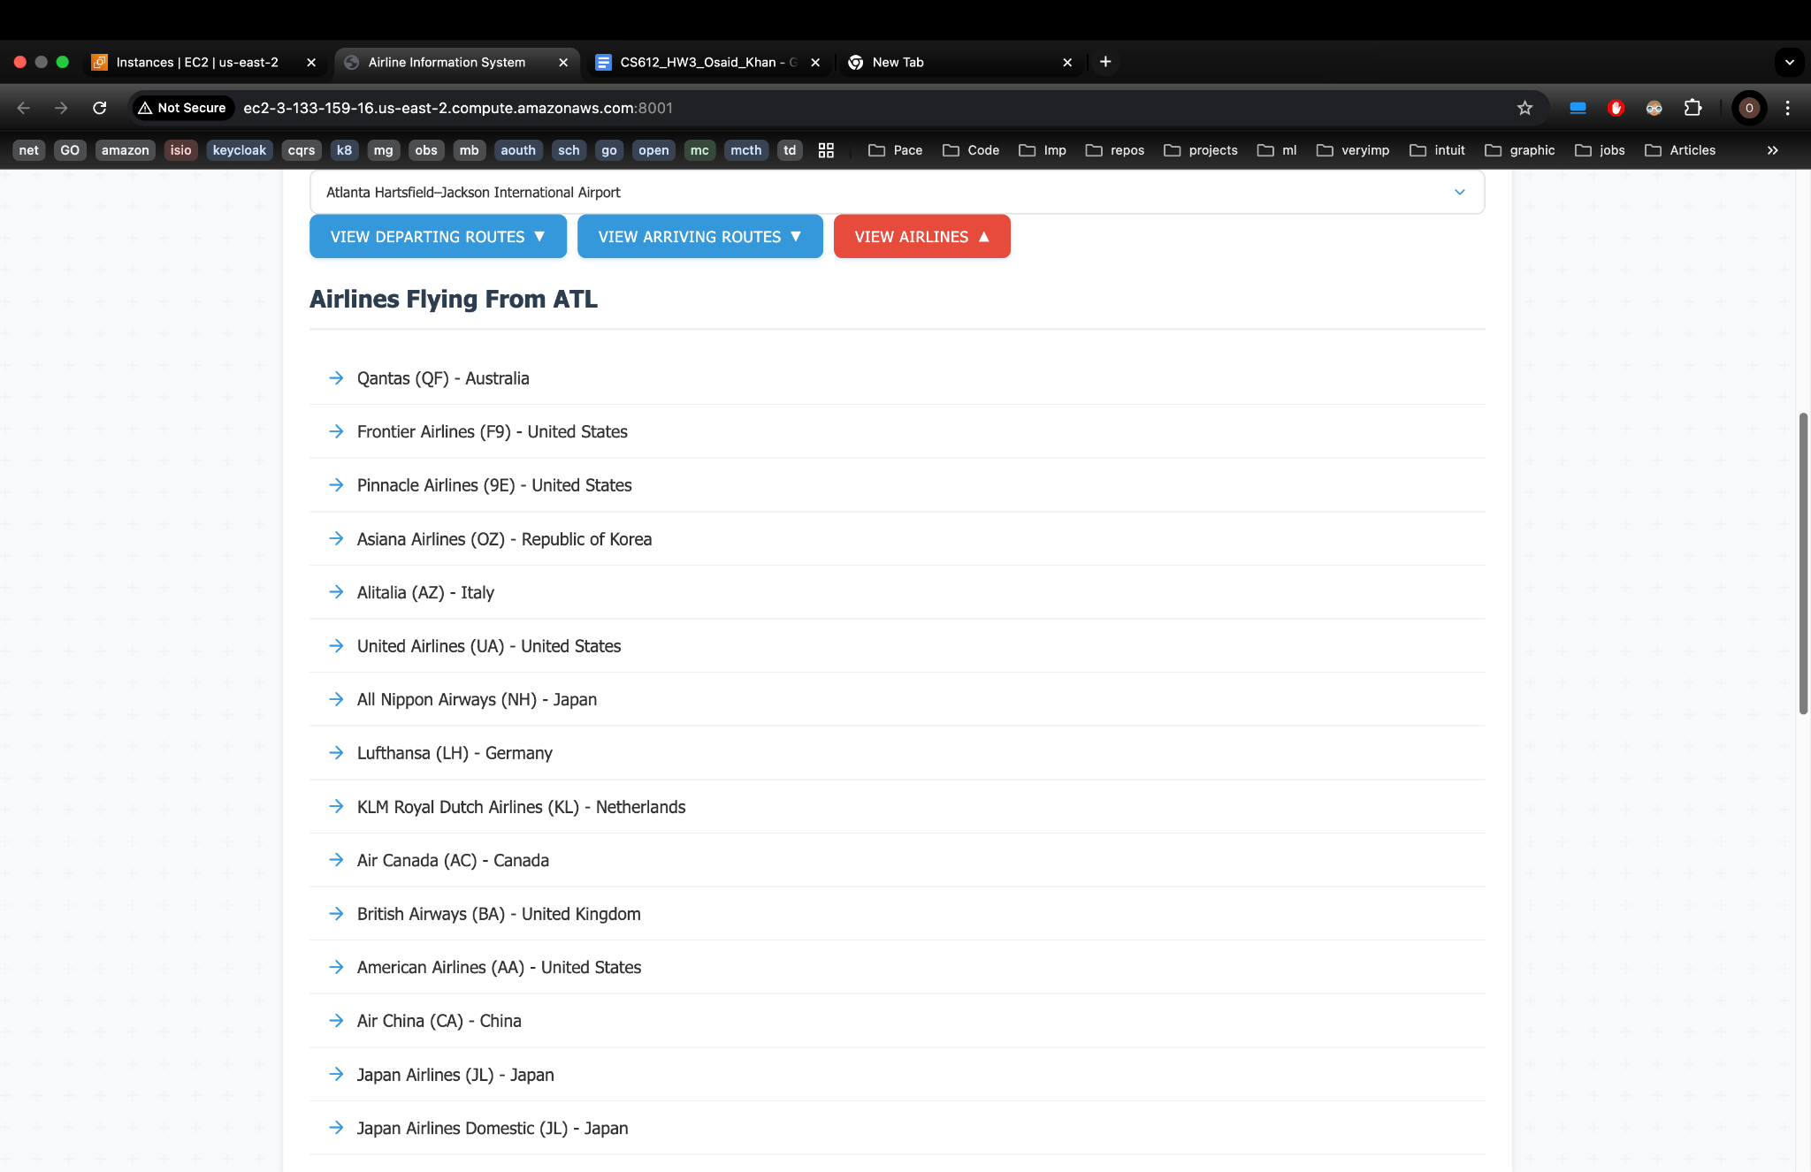

1. **To Test Requirement - “A user selects a pair of the airports to view all airlines flying between the airports selected” and “A user selects a pair of the airports to view the distance between the airports selected”**
2. Go to the bottom of the page Select the **Arrival** and **Departure** Airports
3. Click on button **View Route Details’**

**Expected Result ->**

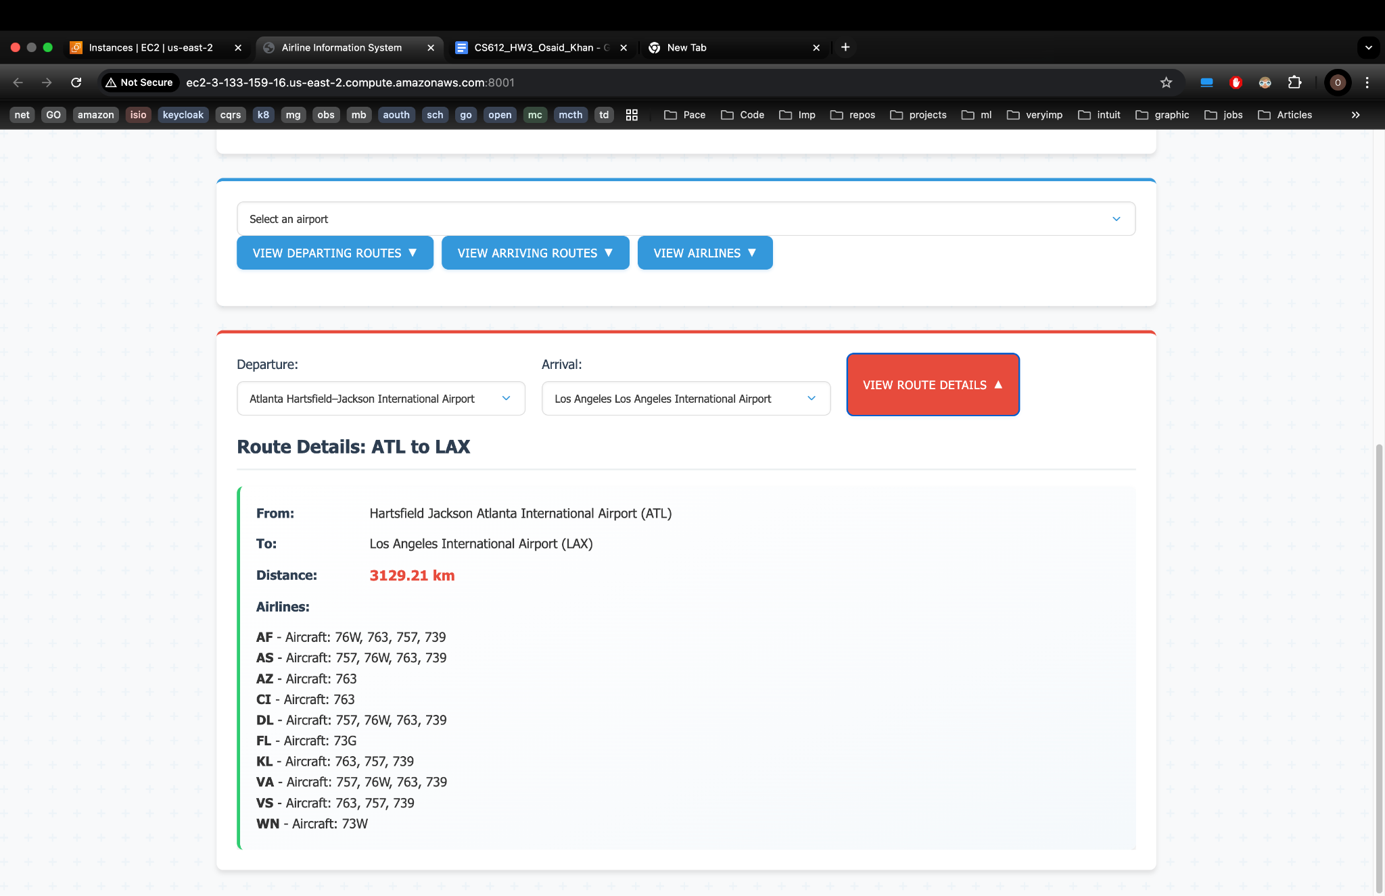

**Q) What additional features outside the mandatory requirements were implemented, and why?**

**Ans)** Inorder to implement “**A user selects an airline to view the airports and/or routes the airline selected flies.”** functionality added an extra endpoint an extra airline endpoint   
  
**1) Get routes by airline code**

* Method: **GET**
* URL: /airline/routes?code=AIRLINE_CODE
* Description: Returns information about an airline and all its routes.
* **Parameters: code (required) - airline IATA or ICAO code**
* **Output Format -**

{

"airline": {

"name": "Airline Name",

"iata": "IATA code",

"icao": "ICAO code"

},

"routes": [

{

"airline": "Airline code",

"departure_code": "Departure airport code",

"arrival_code": "Arrival airport code",

"planes": ["Aircraft types"],

"departure_airport": "Departure airport name",

"departure_city": "Departure city",

"departure_country": "Departure country",

"arrival_airport": "Arrival airport name",

"arrival_city": "Arrival city",

"arrival_country": "Arrival country"

}

],

"count": 42 // Total number of routes

}

**Command**

**curl -X GET "http://ec2-3-133-159-16.us-east-2.compute.amazonaws.com:8001//airline/routes?code=AA"**

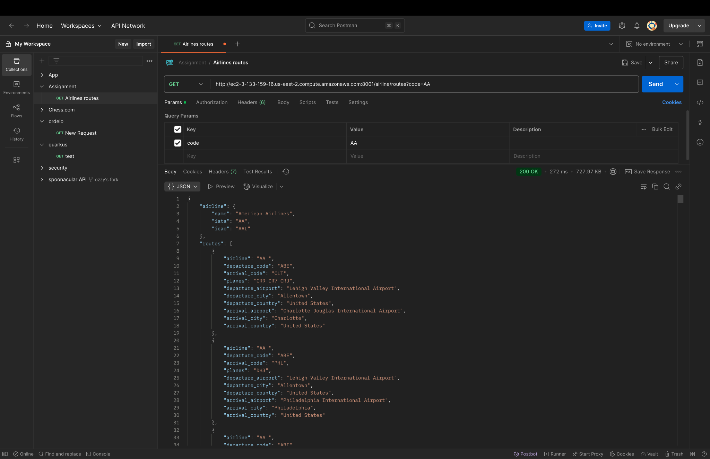

**2)** In order to implement  **“A user selects an airport to view the routes arriving at the airport selected**”. and “**A user selects an airport to view all airlines flying to/from the airports selected”** Functionality two more get endpoints where added ->

**Get arrival airports from a departure point**

* Method: **GET**
* URL: /routes/arrivals?departure=DEPARTURE_CODE
* Description: Returns a list of all destination airports that can be reached from the specified departure airport.
* **Parameters: departure (required) - departure airport IATA code**
* **Output ->**

**curl -X GET** [**http://ec2-3-133-159-16.us-east-2.compute.amazonaws.com:8001/routes/arrivals?departure=JFK**](http://ec2-3-133-159-16.us-east-2.compute.amazonaws.com:8001/routes/arrivals?departure=JFK) 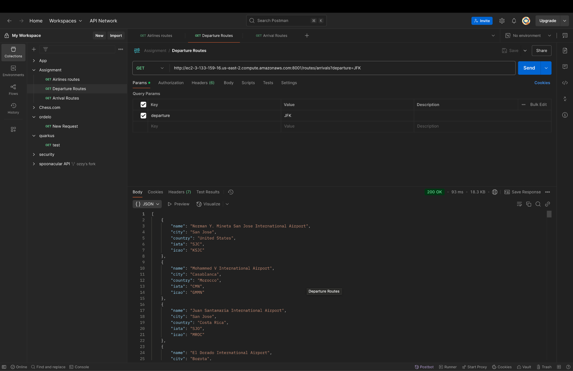

**Get departure airports to an arrival point**

* Method: **GET**
* URL: /routes/departures?arrival=ARRIVAL_CODE
* Description: Returns a list of all origin airports that have routes to the specified arrival airport.
* **Parameters: arrival (required) - arrival airport IATA code**
* **Output Format**

**curl -X GET "**[**http://ec2-3-133-159-16.us-east-2.compute.amazonaws.com:8001/routes/departures?arrival=LHR**](http://ec2-3-133-159-16.us-east-2.compute.amazonaws.com:8001/routes/departures?arrival=LHR)**"**

